DAM 2 Final Project Paper

Darlington Sabasi
Marshall Smith
April 18, 2024

Background
For my project, I chose to analyze correlation of real-world statistics. The first correlation I decided to analyze was how income affected homicide rates within a state. I have always been curious if higher poverty areas had higher homicide rates and decided to use data from 2018 for this study. Typically, areas with higher crime are areas with high poverty rates and I was curious to see if there was a direct correlation between the two or if it was just merely a coincidence. For example, one would think that it would be safer to walk through Beverly Hills with a gold chain and an expensive coat than it would be to walk through a higher poverty area with the same chain and coat. Granted this is all assumed and by no means backed up by evidence at this point. That is why I wanted to supply the evidence so that we could determine if this thought process was true.
The second correlation I decided to analyze was how homicide rates affected life expectancy within a state. It is natural to assume that higher homicide rates would decrease the life expectancy of an individual living in that state. What sparked this question is the life expectancy of gang members in inner cities. It is common knowledge that gang members live in communities with high crime rates and often become victims of homicides before they reach adulthood. If someone is constantly put in a dangerous situation, their life expectancy is assumed to be lower than someone who lives in a lower crime area. Of course, this is all based on assumption and is in no way backed up by statistics. That is why I took the liberty of observing the statistics and creating my own hypothesis.
My null hypothesis for the first correlation is that there is no relationship between median household income and homicide rate. My alternative hypothesis is that there is a relationship between median household income and homicide rate. The type of hypothesis that I made to help assess the data is a correlative null hypothesis. This means that there is no relationship between one piece of data and another. My alternative hypothesis would be a correlative hypothesis which means there is a relationship between two pieces of data.
My null hypothesis for the second correlation was that there is not a significant relationship between life expectancy at birth and homicide rate. This means that changes in median income do not lead to changes in homicide rate. I chose this as my null hypothesis because it is safe to assume that there is no effect or observed difference until evidence suggests otherwise. It essentially sets the expectation that any observed differences are purely by chance with no correlation. My alternative hypothesis is that there is a significant relationship between life expectancy at birth and homicide rate. This means that there is a correlation between life expectancy and homicide rate.
Research Methodologies
The research methodologies that I used include descriptive analysis, inferential analysis, correlation analysis, simulation analysis, simulation studies, and A/B testing. The main methodology that I used was a correlation analysis. This methodology aims to examine the relationship between multiple variables without manipulating them. It is important to use the data given so that we can develop a true understanding for what the data means. In case number one, I was interested in understanding how changes in median income might be associated with changes in homicide rate across the United States. In case number two, I was interested in understanding how homicide rates might be associated with life expectancy within a specific state. I chose this methodology because it has real-world application. I selected these variables based on theoretical considerations and prior research that suggested a potential link between socioeconomic factors such as income and crime rates. I was also curious if lower homicide rates meant a higher life expectancy. This information could be vital in choosing where to live in the future and when choosing where I want to raise my children.
I used descriptive analysis when I summarized my findings and described the main features of my dataset. Some examples of this would be calculating the means and medians of the data. Along with descriptive analysis, I also used inferential statistics. I utilized this to draw conclusions and make inferences about the population based on the data I gathered while also using techniques such as hypothesis testing and the implementation of confidence intervals.
Another kind of research methodology that I used was comparative analysis. I did this by comparing different groups, such as states with different median incomes, homicide rates, and life expectancy. Comparative analysis was used to assess the similarities and differences between these different groups. To ensure a good comparative analysis, I had to use A/B testing to compare the two different groups to see if there are significant differences or similarities between them. To ensure that I was getting the most accurate results, I performed a simulation study to see how different conditions or assumptions affected the data and certain outcomes.
Data Collection and Sampling
To collect data, I went to government websites where I found data such as Homicide rate, life expectancy, and median household income. This data was gathered for statistical tests and analysis. More specifically, correlation analysis and hypothesis testing. I gathered my homicide data along with my life expectancy data from the CDC. This page was made so that each state could be clicked on a reveal statistic such as fertility rate, life expectancy, divorce rate and homicide rate. To use this data, I had to make a separate spreadsheet and sift through all the information to ensure that I had the correct and most effective data. I then added the homicide and life expectancy data for each state individually into my spreadsheet.
I gathered my median household income data from census.gov. This datasheet contained data from multiple years, so I adjusted the datasheet so that we could analyze and assess only one year. I chose 2018, as the year for my data analysis. I then combined the two datasheets so that I could load one table into Jupyter without having to worry about combining them later in the analysis.
After this data was put into a single spreadsheet and loaded into python, I had to manipulate the data to ensure that all columns and rows were not empty and contained data.
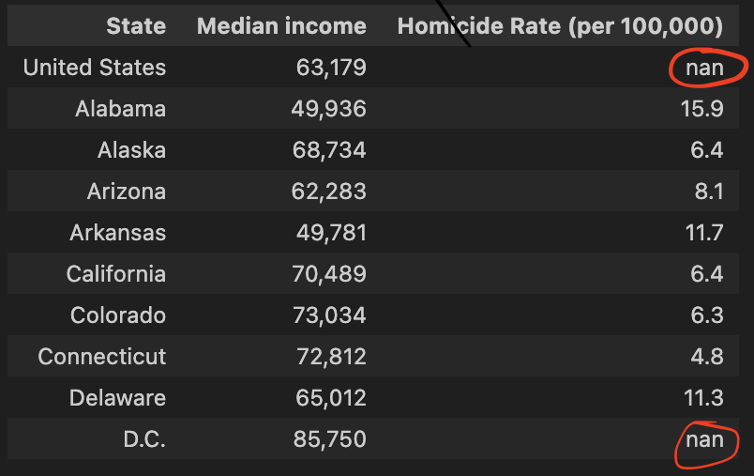

An example of this is shown in figure 1. The ‘nan’ represent data that is not available to analyze and therefore not useful for my analysis. To fix this, I had to write code that cleaned the data to only return rows that had information for every column.
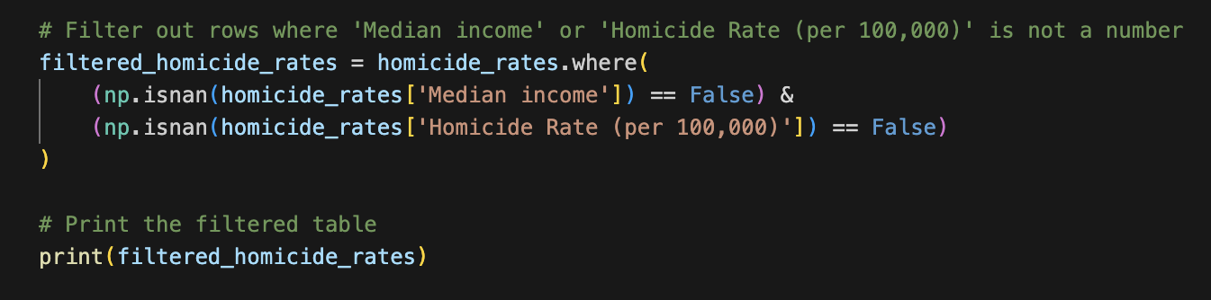

I used the ‘np.isnan()’ function to identify NaN (not a number) values. If the condition came back as true, then it means the value is a number and could therefore be used in analysis. This code helped to ensure that only rows with valid numerical data for both ‘Median Income’ and ‘Homicide Rate’ are retained in the table ‘filtered_homicide_rates’, facilitating further analysis without potential disruptions caused by missing data.
Data Overview
To assess if I could see a visual correlation, I plotted a histogram with ‘Homicide Rate’ as my y-axis and ‘Life Expectancy’ as my x-axis.
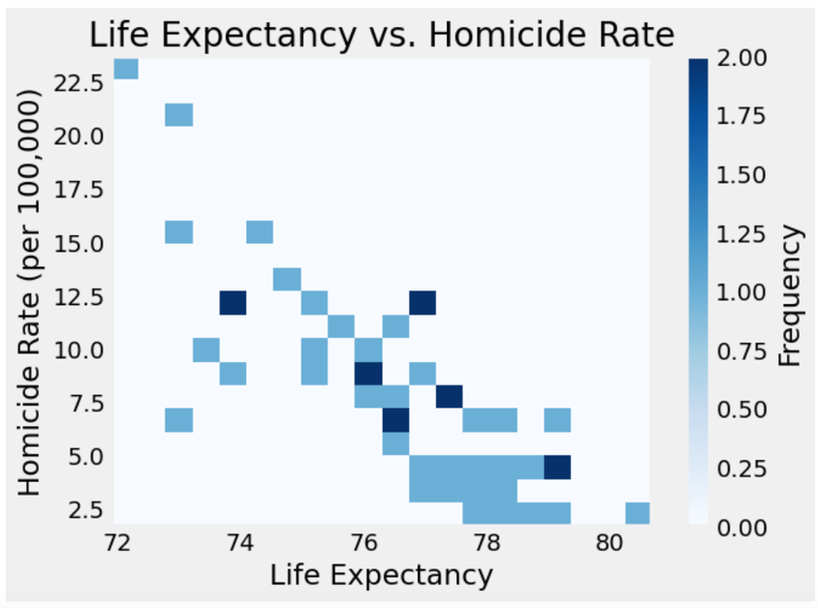
At first glance, the histogram seems to show a moderate correlation between life expectancy and homicide rate. The correlation appears to be negative, meaning that the higher the homicide rate, the lower the life expectancy. I proceeded to create a line of best-fit to examine it further.
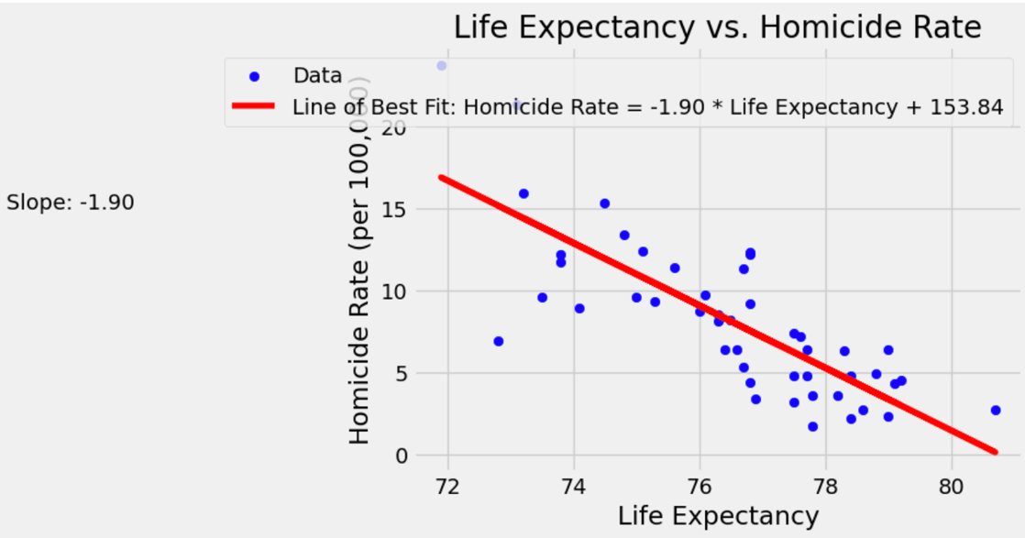
This line of best fit slopes downwards, which reaffirms our theory that there is a moderate negative correlation between homicide rate and life expectancy. This indicates that as life expectancy increased, the homicide rate decreases. The steepness of the slope is also telling. A steeper slope indicates a stronger relationship while a shallower slope suggests a weaker relationship. In this case, the slope is -1.90. This indicates that the strength of the correlation is moderate to weak.
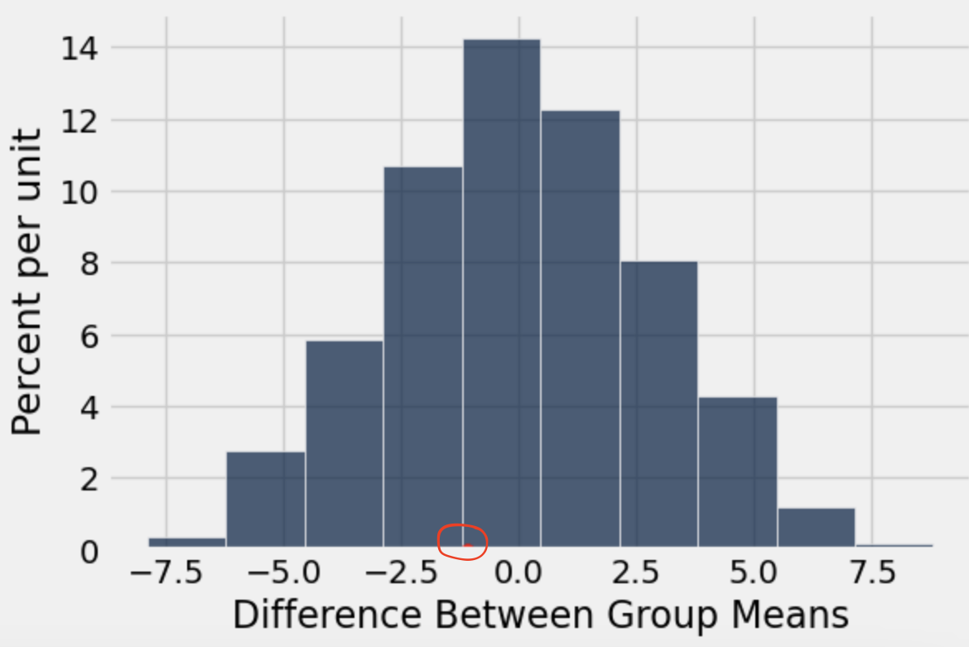
After I calculated group means, I created a histogram to assess and visualize the distribution of differences between those group means. Each bar represents a range of differences, and the height of each bar indicates the frequency of observations falling within that range of differences. If the histogram is organized in a symmetric non-random pattern, then that would indicate that the differences between groups are by random chance and may not be statistically significant. This histogram also contains a red dot which represents the observed difference between group means. If the dot is farther out on the tails, then it would indicate there is more correlation than just random chance. In this case, the dot is near the middle which means the observed difference is more typical and may not be statistically significant.
Hypothesis Testing
For question 1, my null hypothesis is that there is no significant relationship between median income and homicide rate. My alternative hypothesis was that there is a significant negative relationship between median income and homicide rate. To separate and understand the groups, I divided them into two groups: states with a median income above $50,000 and a median income below $50,000. Therefore, my test statistic was the observed difference in the average homicide rate between states with median incomes above $50,000 and those with median incomes below or equal to $50,000. To determine the p-value, I employed a permutation test to compare group means and assess the relationship between variables like median income and homicide rate. Additionally, I utilized a bootstrap test to gauge the variability of statistics, particularly focusing on means.
For my second inquiry, my null hypothesis is that there is no significant relationship between life expectancy and homicide rate. My alternative hypothesis is that there is a significant relationship between life expectancy at birth and homicide rate. My test statistic was the observed difference in the life expectancy between states with a homicide rate above 5, and those with a homicide rate below or equal to 5. I took the same steps to determine p-value.
Interpreting the Results
For question number 1, I found the correlation between median household income and homicide rates per state to have a p-value of 0.9812. Using a 5% p-value cutoff, we would fail to reject the null hypothesis. This means that there is no direct correlation between poverty level and homicide rates. This p-value implies that the ‘correlation’ is merely just chance or there are other factors affecting homicide rate more.
For question number 2, I found the correlation between homicide rates and life expectancy per state to have a p-value of 0.6564. using a 5% p-value cutoff, we again fail to reject the null hypothesis. This means that there is no direct correlation between homicide rates and life expectancy. A p-value of .65 means that in 65% of the simulated trials, the observed differences between the groups occurred by random chance alone. This p-value is much closer to being significant than the other p-value that we calculated. I took a frequentist approach because I relied on p-values to make statistical inferences. I took this approach because the Bayesian approach would be to incorporate prior knowledge about parameters being estimated. This would have led me to believe there was a correlation between homicide rates, life expectancy and median household income. As I have previously stated, that is not the case. I took a frequentist approach to make my decisions based on statistics and not worldly knowledge. This is important because there are other factors that go into affecting things such as life expectancy and homicide rate.
Conclusion
In this study, I aimed to investigate the relationship between median income and homicide rate, as well as how homicide rate affects life expectancy at birth. I utilized statistical analysis techniques such as hypothesis testing, correlation analysis, and linear regression to explore these relationships. This research is significant because understanding these connections can inform public policy decisions, resource allocation, and intervention strategies aimed at reducing crime and improving public health outcomes. My findings revealed that there is not a statistically significant association between median income and homicide rate, with lower income areas experiencing higher homicide rates. Additionally, I found that higher homicide rates are not associated with lower life expectancy. Therefore, I failed to reject the null hypothesis and conclude that there is no evidence to support the alternative hypotheses proposed in my study.

References
Centers for Disease Control and Prevention. (2022, March 2). Stats of the States - Homicide Mortality. Centers for Disease Control and Prevention. https://www.cdc.gov/nchs/pressroom/sosmap/homicide_mortality/homicide.htm
Table H-8. median household income by State. Census.gov. (n.d.). https://www2.census.gov/programs-surveys/cps/tables/time-series/historical-income-households/h08.xls

